Contents

Configuration of Vagrant Virtual Box having private and public network accessed from local machine 2

Configuration of both private and public network for vagrant box 2

Installation of Apache and NGINX 3

Ifconfig 3

/etc/apache2/ports.conf 4

Monitoring the status if it is running or not 4

Installation of mysql database 5

Configuration of a user and password for a specific user and pwd 5

USER Checking 5

Port checking 5

**TABLE OF FIGURES**

Figure 1: Configuration of private network 3

Figure 2: Configuration of Public Network 3

Figure 3: Installation of apache 4

Figure 4: Installation of NGINX 4

Figure 5: Checking the ip address 4

Figure 6: Changing the port of apache 5

Figure 7: Running of both apache and nginx at the same time 5

Figure 8: Installation of mysql-server 6

Figure 9: Creation of a user and password 6

Figure 10: Checking of the user 6

Figure 11: Port checking 6

# 

# Configuration of Vagrant Virtual Box having private and public network accessed from local machine

#Author: Sudip Prajapati

#Date: November 03,2021

## Configuration of both private and public network for vagrant box

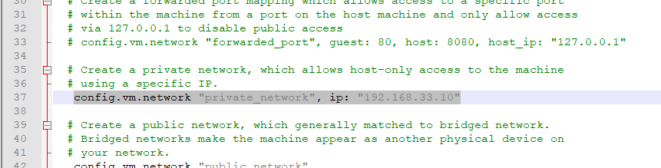

Figure : Configuration of private network

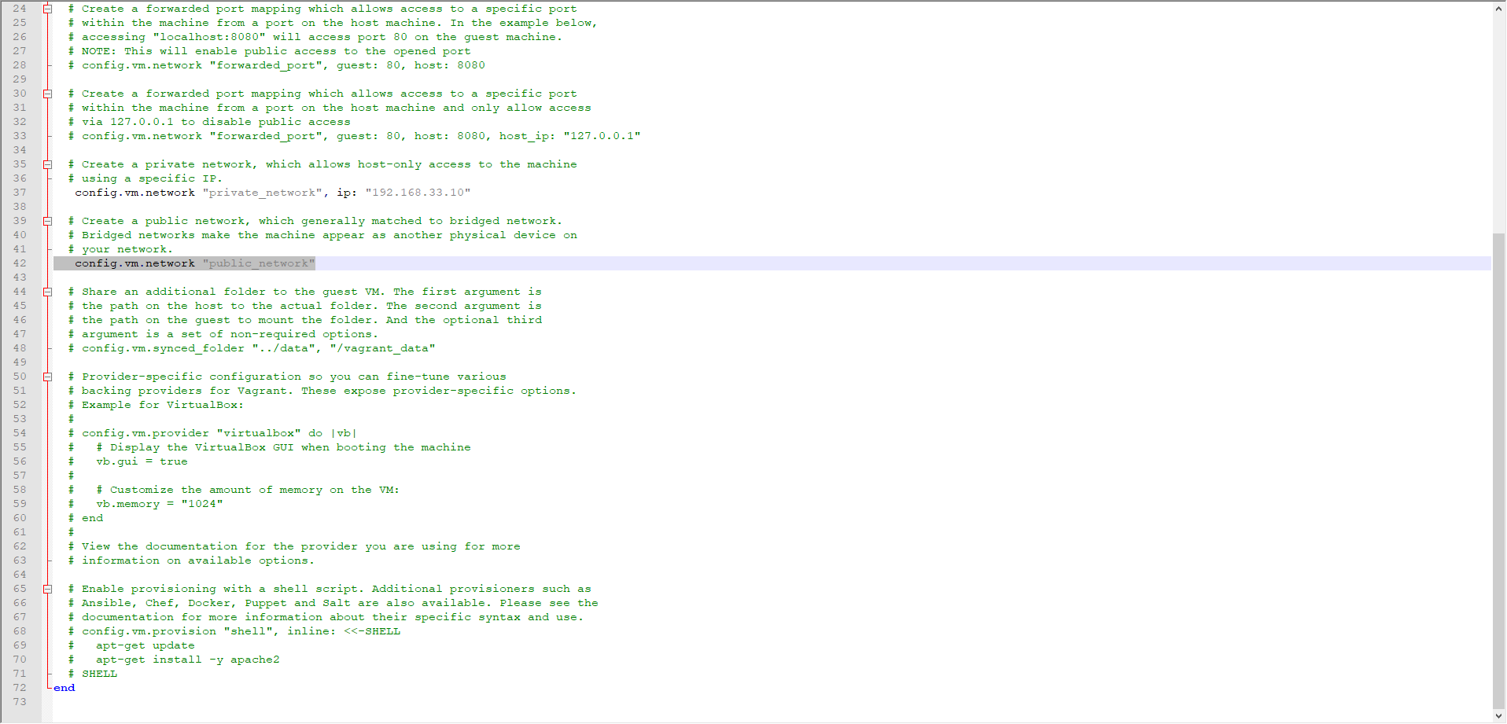

Figure : Configuration of Public Network

## Installation of Apache and NGINX

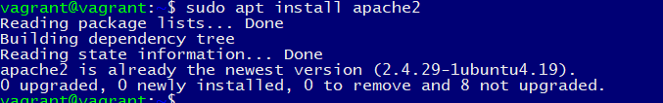

Figure : Installation of apache



Figure : Installation of NGINX

## Ifconfig

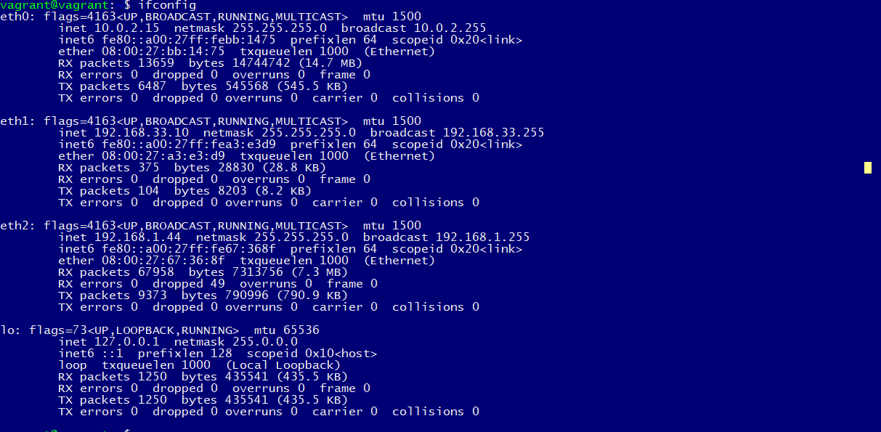

Figure : Checking the ip address

## /etc/apache2/ports.conf

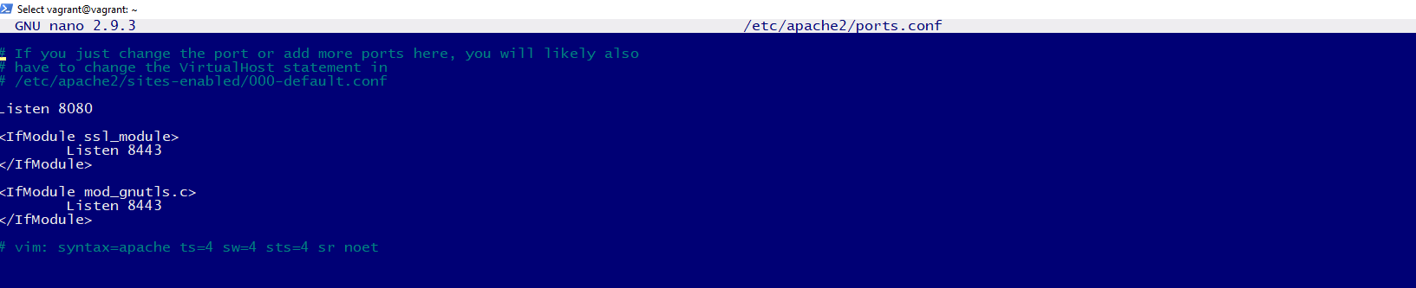

Figure : Changing the port of apache

## Monitoring the status if it is running or not

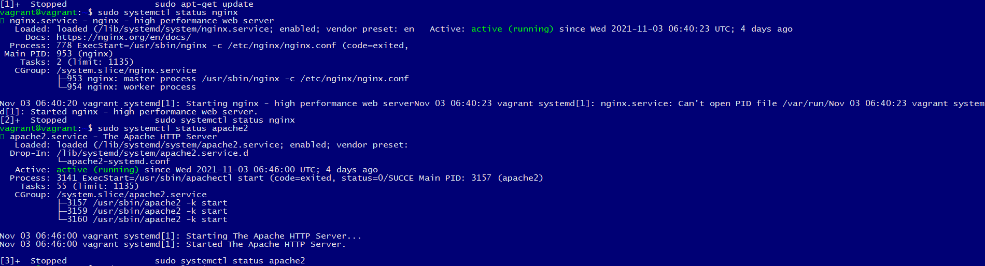

Figure : Running of both apache and nginx at the same time

## Installation of mysql database



Figure : Installation of mysql-server

## Configuration of a user and password for a specific user and pwd



Figure : Creation of a user and password

## USER Checking

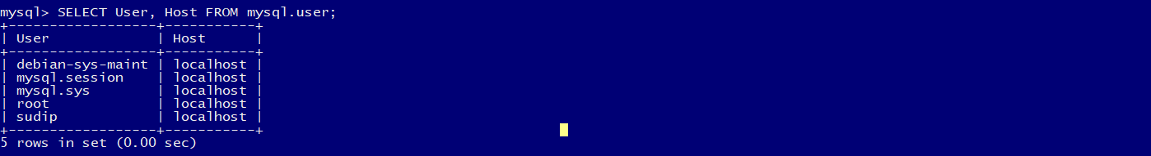

Figure : Checking of the user

## Port checking

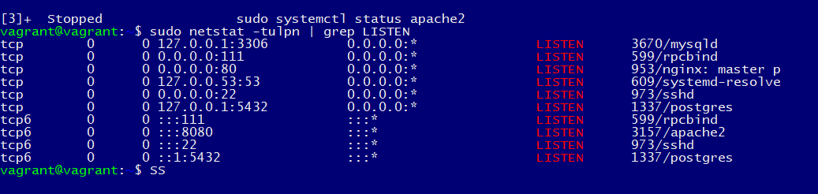

Figure : Port checking